

**Amazon Sales Analysis**

**PROBLEM STATEMENT :-**

1. **How to generate Big Revenue**

Filpkart started its sales and was able to generate maximum revenue the most money on its Big Billion Days.

**KPI:** Sales over some time.

**CTQ:** Both company and customers of the company.

**B) Supply chain optimization:-**

To maintain its supply chain, Filpkart can deliver quickly, but this is only possible if there is stock in the customer's city.

**KPI:** Quantity of items ordered in the location**.**

**CTQ:** Cost-efficient to the company and experience for the customers.

1. **Recommendation System**

Which city's residents would purchase most frequently if the item was available there?.

**KPI**: Quantity of Products ordered matched by same Order IDs.

**CTQ:** Company will benefit most as they will be able to sell more product.

**Measure:-**

The data include the following features:

* Order id:- Also known as Purchase ID.Identifies a purchase or order placed by a buyer.
* Product:- Number of procuct service you sell to serve a customer's
* Quanitaty order:- Number of unit of product
* Price each:- Price of each item
* Order Date:- Decision and Order becomes final.
* Purchase Address:- Address a buyer or receiver

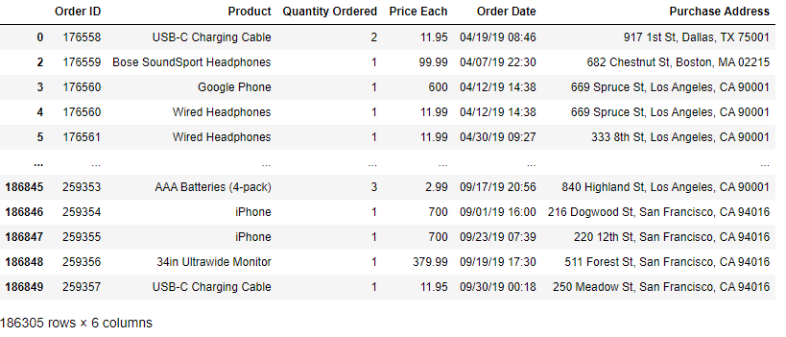

**Analyze**

Created three bar graphs. Which month, what day, and what hour should the large billlion sale begin in order to gentrate more and more revenue and income.

**Months & Sales** 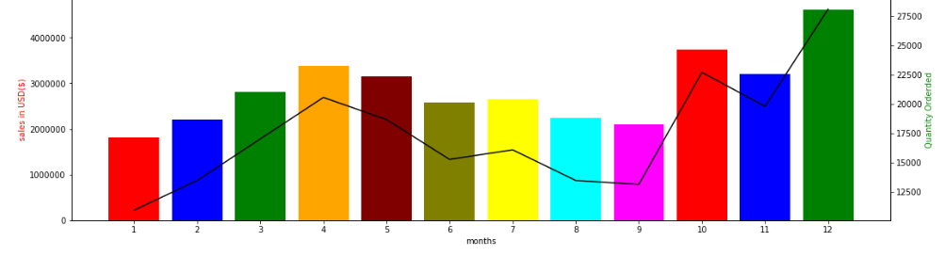

**Days & QuantityOrdered**

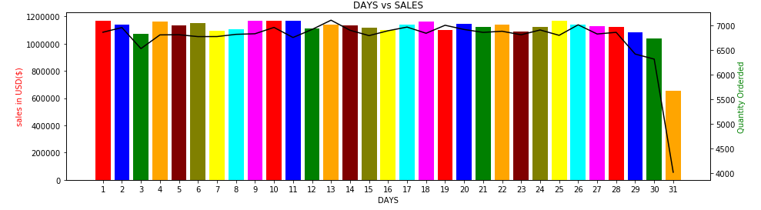

**Hours & sales**

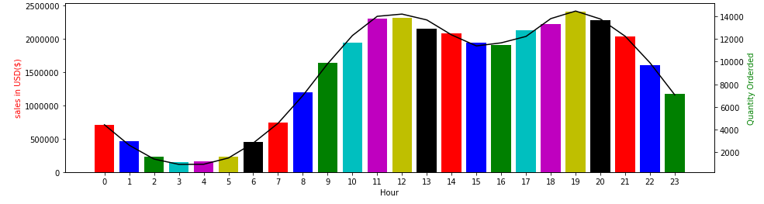

Seen in the graph during the big billion also need to good supply chain optimization that which city generates most revenue from our products.

**Top 5 products & Sales**

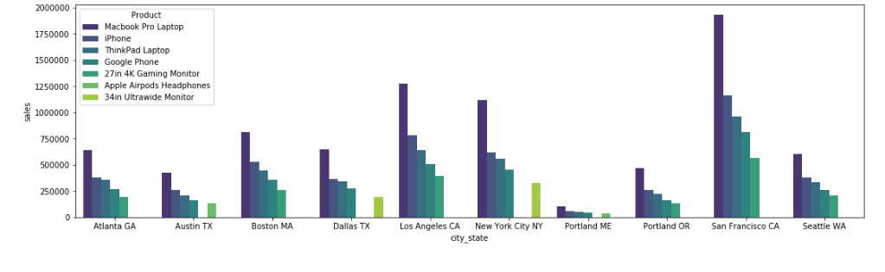

Created a group of items ordered by people together by matching the Order IDs. visualizations are generated displaying the purchases made by customers in a set of 2 and 3 items together

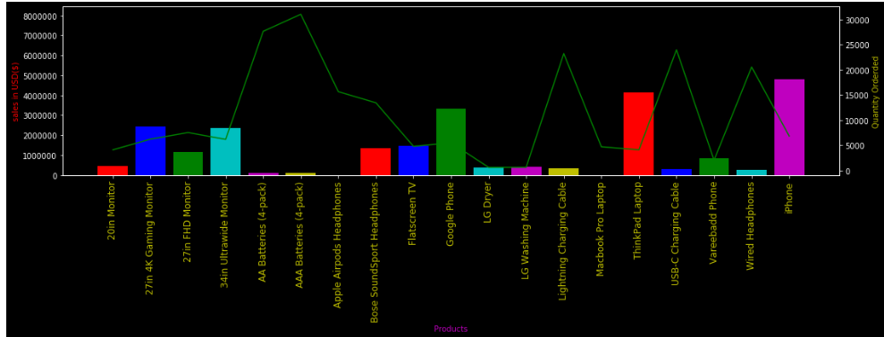

C:\Users\ADMIN\Desktop\aaft-logo.png

My name is **Amit Singh Yadav**, and I am a passionate data science enthusiast. I am pleased to present my analysis on **Amazon**, where I have delved into various aspects of the company to gain valuable insights. Through this report, I aim to provide a comprehensive understanding of Amazon's performance, strategies, and potential opportunities.